Любенова, В. Римска военна диплома от Перник.
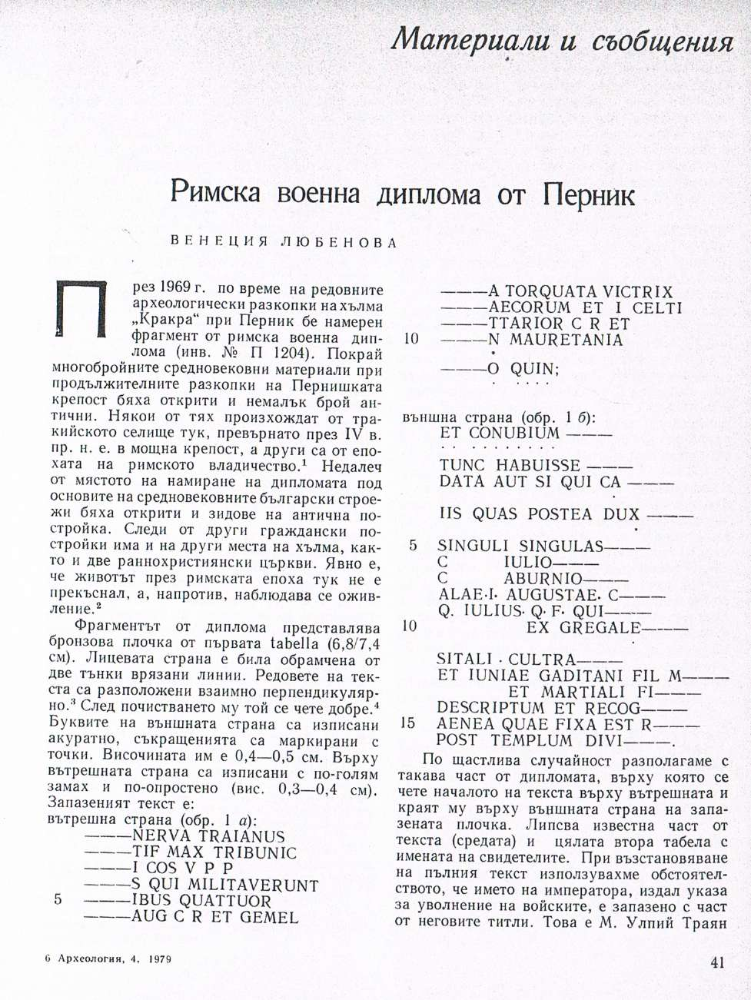

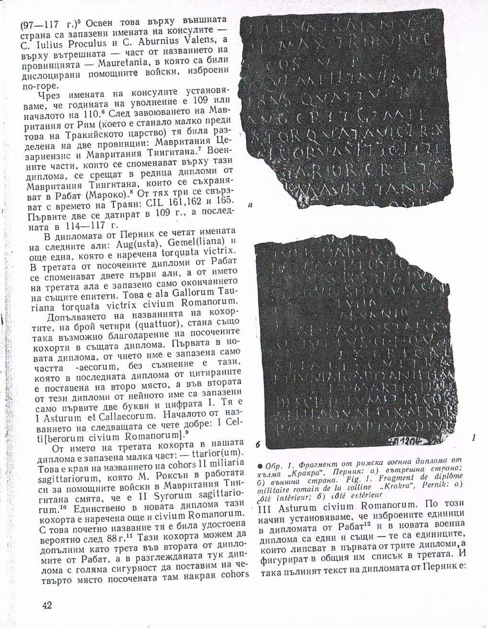

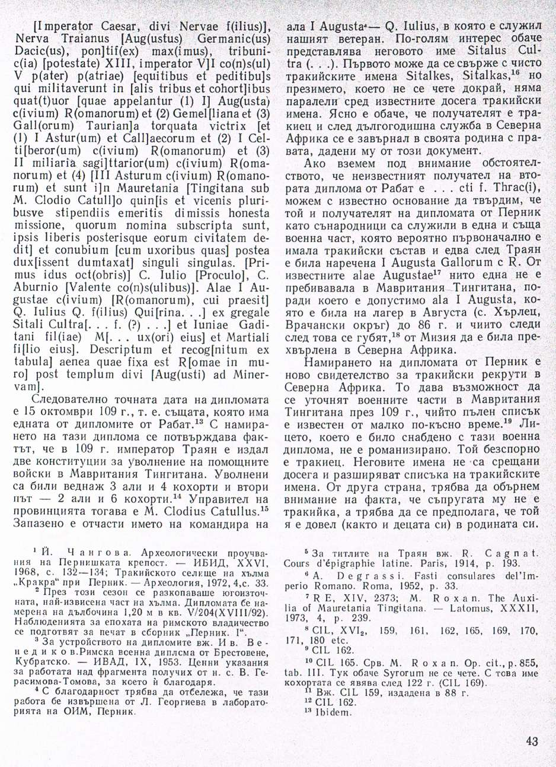

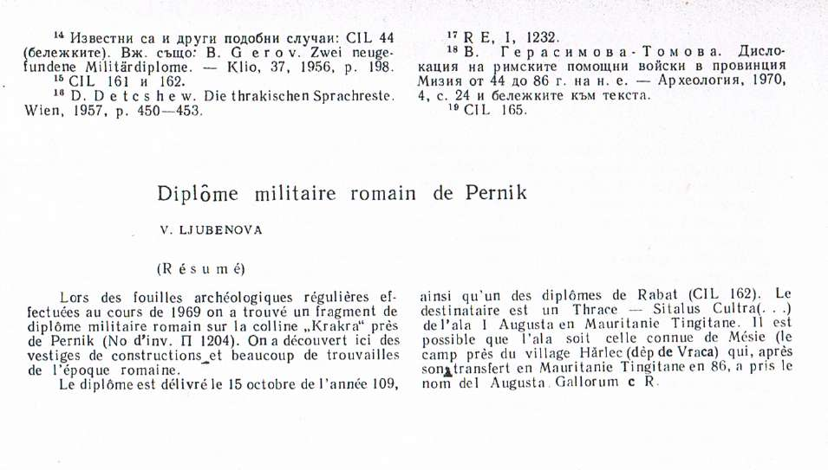

Любенова, В. Римска военна диплома от Перник. А., 1979, 4, с. 41-44.

INCLUDEPICTURE "http://t0.gstatic.com/images?q=tbn:ANd9GcTDT1jpfS6n_Y4NmsXFnf0dV2uAk854tEHeOSaIXPxUCt7qxHu5xaSaZA" \* MERGEFORMATINET INCLUDEPICTURE "http://t0.gstatic.com/images?q=tbn:ANd9GcTDT1jpfS6n_Y4NmsXFnf0dV2uAk854tEHeOSaIXPxUCt7qxHu5xaSaZA" \* MERGEFORMATINET INCLUDEPICTURE "http://t0.gstatic.com/images?q=tbn:ANd9GcTDT1jpfS6n_Y4NmsXFnf0dV2uAk854tEHeOSaIXPxUCt7qxHu5xaSaZA" \* MERGEFORMATINET INCLUDEPICTURE "http://t0.gstatic.com/images?q=tbn:ANd9GcTDT1jpfS6n_Y4NmsXFnf0dV2uAk854tEHeOSaIXPxUCt7qxHu5xaSaZA" \* MERGEFORMATINET INCLUDEPICTURE "http://t0.gstatic.com/images?q=tbn:ANd9GcTDT1jpfS6n_Y4NmsXFnf0dV2uAk854tEHeOSaIXPxUCt7qxHu5xaSaZA" \* MERGEFORMATINET INCLUDEPICTURE "http://t0.gstatic.com/images?q=tbn:ANd9GcTDT1jpfS6n_Y4NmsXFnf0dV2uAk854tEHeOSaIXPxUCt7qxHu5xaSaZA" \* MERGEFORMATINET INCLUDEPICTURE "http://t0.gstatic.com/images?q=tbn:ANd9GcTDT1jpfS6n_Y4NmsXFnf0dV2uAk854tEHeOSaIXPxUCt7qxHu5xaSaZA" \* MERGEFORMATINET INCLUDEPICTURE "http://t0.gstatic.com/images?q=tbn:ANd9GcTDT1jpfS6n_Y4NmsXFnf0dV2uAk854tEHeOSaIXPxUCt7qxHu5xaSaZA" \* MERGEFORMATINET INCLUDEPICTURE "http://t0.gstatic.com/images?q=tbn:ANd9GcTDT1jpfS6n_Y4NmsXFnf0dV2uAk854tEHeOSaIXPxUCt7qxHu5xaSaZA" \* MERGEFORMATINET INCLUDEPICTURE "http://t0.gstatic.com/images?q=tbn:ANd9GcTDT1jpfS6n_Y4NmsXFnf0dV2uAk854tEHeOSaIXPxUCt7qxHu5xaSaZA" \* MERGEFORMATINET INCLUDEPICTURE "http://t0.gstatic.com/images?q=tbn:ANd9GcTDT1jpfS6n_Y4NmsXFnf0dV2uAk854tEHeOSaIXPxUCt7qxHu5xaSaZA" \* MERGEFORMATINET INCLUDEPICTURE "http://t0.gstatic.com/images?q=tbn:ANd9GcTDT1jpfS6n_Y4NmsXFnf0dV2uAk854tEHeOSaIXPxUCt7qxHu5xaSaZA" \* MERGEFORMATINET INCLUDEPICTURE "http://t0.gstatic.com/images?q=tbn:ANd9GcTDT1jpfS6n_Y4NmsXFnf0dV2uAk854tEHeOSaIXPxUCt7qxHu5xaSaZA" \* MERGEFORMATINET INCLUDEPICTURE "http://t0.gstatic.com/images?q=tbn:ANd9GcTDT1jpfS6n_Y4NmsXFnf0dV2uAk854tEHeOSaIXPxUCt7qxHu5xaSaZA" \* MERGEFORMATINET INCLUDEPICTURE "http://t0.gstatic.com/images?q=tbn:ANd9GcTDT1jpfS6n_Y4NmsXFnf0dV2uAk854tEHeOSaIXPxUCt7qxHu5xaSaZA" \* MERGEFORMATINET INCLUDEPICTURE "http://t0.gstatic.com/images?q=tbn:ANd9GcTDT1jpfS6n_Y4NmsXFnf0dV2uAk854tEHeOSaIXPxUCt7qxHu5xaSaZA" \* MERGEFORMATINET INCLUDEPICTURE "http://t0.gstatic.com/images?q=tbn:ANd9GcTDT1jpfS6n_Y4NmsXFnf0dV2uAk854tEHeOSaIXPxUCt7qxHu5xaSaZA" \* MERGEFORMATINET INCLUDEPICTURE "http://t0.gstatic.com/images?q=tbn:ANd9GcTDT1jpfS6n_Y4NmsXFnf0dV2uAk854tEHeOSaIXPxUCt7qxHu5xaSaZA" \* MERGEFORMATINET INCLUDEPICTURE "http://t0.gstatic.com/images?q=tbn:ANd9GcTDT1jpfS6n_Y4NmsXFnf0dV2uAk854tEHeOSaIXPxUCt7qxHu5xaSaZA" \* MERGEFORMATINET INCLUDEPICTURE "http://t0.gstatic.com/images?q=tbn:ANd9GcTDT1jpfS6n_Y4NmsXFnf0dV2uAk854tEHeOSaIXPxUCt7qxHu5xaSaZA" \* MERGEFORMATINET INCLUDEPICTURE "http://t0.gstatic.com/images?q=tbn:ANd9GcTDT1jpfS6n_Y4NmsXFnf0dV2uAk854tEHeOSaIXPxUCt7qxHu5xaSaZA" \* MERGEFORMATINET INCLUDEPICTURE "http://t0.gstatic.com/images?q=tbn:ANd9GcTDT1jpfS6n_Y4NmsXFnf0dV2uAk854tEHeOSaIXPxUCt7qxHu5xaSaZA" \* MERGEFORMATINET INCLUDEPICTURE "http://t0.gstatic.com/images?q=tbn:ANd9GcTDT1jpfS6n_Y4NmsXFnf0dV2uAk854tEHeOSaIXPxUCt7qxHu5xaSaZA" \* MERGEFORMATINET INCLUDEPICTURE "http://t0.gstatic.com/images?q=tbn:ANd9GcTDT1jpfS6n_Y4NmsXFnf0dV2uAk854tEHeOSaIXPxUCt7qxHu5xaSaZA" \* MERGEFORMATINET INCLUDEPICTURE "http://t0.gstatic.com/images?q=tbn:ANd9GcTDT1jpfS6n_Y4NmsXFnf0dV2uAk854tEHeOSaIXPxUCt7qxHu5xaSaZA" \* MERGEFORMATINET INCLUDEPICTURE "http://t0.gstatic.com/images?q=tbn:ANd9GcTDT1jpfS6n_Y4NmsXFnf0dV2uAk854tEHeOSaIXPxUCt7qxHu5xaSaZA" \* MERGEFORMATINET INCLUDEPICTURE "http://t0.gstatic.com/images?q=tbn:ANd9GcTDT1jpfS6n_Y4NmsXFnf0dV2uAk854tEHeOSaIXPxUCt7qxHu5xaSaZA" \* MERGEFORMATINET INCLUDEPICTURE "http://t0.gstatic.com/images?q=tbn:ANd9GcTDT1jpfS6n_Y4NmsXFnf0dV2uAk854tEHeOSaIXPxUCt7qxHu5xaSaZA" \* MERGEFORMATINET INCLUDEPICTURE "http://t0.gstatic.com/images?q=tbn:ANd9GcTDT1jpfS6n_Y4NmsXFnf0dV2uAk854tEHeOSaIXPxUCt7qxHu5xaSaZA" \* MERGEFORMATINET INCLUDEPICTURE "http://t0.gstatic.com/images?q=tbn:ANd9GcTDT1jpfS6n_Y4NmsXFnf0dV2uAk854tEHeOSaIXPxUCt7qxHu5xaSaZA" \* MERGEFORMATINET INCLUDEPICTURE "http://t0.gstatic.com/images?q=tbn:ANd9GcTDT1jpfS6n_Y4NmsXFnf0dV2uAk854tEHeOSaIXPxUCt7qxHu5xaSaZA" \* MERGEFORMATINET INCLUDEPICTURE "http://t0.gstatic.com/images?q=tbn:ANd9GcTDT1jpfS6n_Y4NmsXFnf0dV2uAk854tEHeOSaIXPxUCt7qxHu5xaSaZA" \* MERGEFORMATINET INCLUDEPICTURE "http://t0.gstatic.com/images?q=tbn:ANd9GcTDT1jpfS6n_Y4NmsXFnf0dV2uAk854tEHeOSaIXPxUCt7qxHu5xaSaZA" \* MERGEFORMATINET INCLUDEPICTURE "http://t0.gstatic.com/images?q=tbn:ANd9GcTDT1jpfS6n_Y4NmsXFnf0dV2uAk854tEHeOSaIXPxUCt7qxHu5xaSaZA" \* MERGEFORMATINET INCLUDEPICTURE "http://t0.gstatic.com/images?q=tbn:ANd9GcTDT1jpfS6n_Y4NmsXFnf0dV2uAk854tEHeOSaIXPxUCt7qxHu5xaSaZA" \* MERGEFORMATINET INCLUDEPICTURE "http://t0.gstatic.com/images?q=tbn:ANd9GcTDT1jpfS6n_Y4NmsXFnf0dV2uAk854tEHeOSaIXPxUCt7qxHu5xaSaZA" \* MERGEFORMATINET INCLUDEPICTURE "http://t0.gstatic.com/images?q=tbn:ANd9GcTDT1jpfS6n_Y4NmsXFnf0dV2uAk854tEHeOSaIXPxUCt7qxHu5xaSaZA" \* MERGEFORMATINET INCLUDEPICTURE "http://t0.gstatic.com/images?q=tbn:ANd9GcTDT1jpfS6n_Y4NmsXFnf0dV2uAk854tEHeOSaIXPxUCt7qxHu5xaSaZA" \* MERGEFORMATINET INCLUDEPICTURE "http://t0.gstatic.com/images?q=tbn:ANd9GcTDT1jpfS6n_Y4NmsXFnf0dV2uAk854tEHeOSaIXPxUCt7qxHu5xaSaZA" \* MERGEFORMATINET INCLUDEPICTURE "http://t0.gstatic.com/images?q=tbn:ANd9GcTDT1jpfS6n_Y4NmsXFnf0dV2uAk854tEHeOSaIXPxUCt7qxHu5xaSaZA" \* MERGEFORMATINET INCLUDEPICTURE "http://t0.gstatic.com/images?q=tbn:ANd9GcTDT1jpfS6n_Y4NmsXFnf0dV2uAk854tEHeOSaIXPxUCt7qxHu5xaSaZA" \* MERGEFORMATINET INCLUDEPICTURE "http://t0.gstatic.com/images?q=tbn:ANd9GcTDT1jpfS6n_Y4NmsXFnf0dV2uAk854tEHeOSaIXPxUCt7qxHu5xaSaZA" \* MERGEFORMATINET INCLUDEPICTURE "http://t0.gstatic.com/images?q=tbn:ANd9GcTDT1jpfS6n_Y4NmsXFnf0dV2uAk854tEHeOSaIXPxUCt7qxHu5xaSaZA" \* MERGEFORMATINET INCLUDEPICTURE "http://t0.gstatic.com/images?q=tbn:ANd9GcTDT1jpfS6n_Y4NmsXFnf0dV2uAk854tEHeOSaIXPxUCt7qxHu5xaSaZA" \* MERGEFORMATINET INCLUDEPICTURE "http://t0.gstatic.com/images?q=tbn:ANd9GcTDT1jpfS6n_Y4NmsXFnf0dV2uAk854tEHeOSaIXPxUCt7qxHu5xaSaZA" \* MERGEFORMATINET INCLUDEPICTURE "http://t0.gstatic.com/images?q=tbn:ANd9GcTDT1jpfS6n_Y4NmsXFnf0dV2uAk854tEHeOSaIXPxUCt7qxHu5xaSaZA" \* MERGEFORMATINET INCLUDEPICTURE "http://t0.gstatic.com/images?q=tbn:ANd9GcTDT1jpfS6n_Y4NmsXFnf0dV2uAk854tEHeOSaIXPxUCt7qxHu5xaSaZA" \* MERGEFORMATINET INCLUDEPICTURE "http://t0.gstatic.com/images?q=tbn:ANd9GcTDT1jpfS6n_Y4NmsXFnf0dV2uAk854tEHeOSaIXPxUCt7qxHu5xaSaZA" \* MERGEFORMATINET INCLUDEPICTURE "http://t0.gstatic.com/images?q=tbn:ANd9GcTDT1jpfS6n_Y4NmsXFnf0dV2uAk854tEHeOSaIXPxUCt7qxHu5xaSaZA" \* MERGEFORMATINET INCLUDEPICTURE "http://t0.gstatic.com/images?q=tbn:ANd9GcTDT1jpfS6n_Y4NmsXFnf0dV2uAk854tEHeOSaIXPxUCt7qxHu5xaSaZA" \* MERGEFORMATINET INCLUDEPICTURE "http://t0.gstatic.com/images?q=tbn:ANd9GcTDT1jpfS6n_Y4NmsXFnf0dV2uAk854tEHeOSaIXPxUCt7qxHu5xaSaZA" \* MERGEFORMATINET INCLUDEPICTURE "http://t0.gstatic.com/images?q=tbn:ANd9GcTDT1jpfS6n_Y4NmsXFnf0dV2uAk854tEHeOSaIXPxUCt7qxHu5xaSaZA" \* MERGEFORMATINET INCLUDEPICTURE "http://t0.gstatic.com/images?q=tbn:ANd9GcTDT1jpfS6n_Y4NmsXFnf0dV2uAk854tEHeOSaIXPxUCt7qxHu5xaSaZA" \* MERGEFORMATINET INCLUDEPICTURE "http://t0.gstatic.com/images?q=tbn:ANd9GcTDT1jpfS6n_Y4NmsXFnf0dV2uAk854tEHeOSaIXPxUCt7qxHu5xaSaZA" \* MERGEFORMATINET INCLUDEPICTURE "http://t0.gstatic.com/images?q=tbn:ANd9GcTDT1jpfS6n_Y4NmsXFnf0dV2uAk854tEHeOSaIXPxUCt7qxHu5xaSaZA" \* MERGEFORMATINET INCLUDEPICTURE "http://t0.gstatic.com/images?q=tbn:ANd9GcTDT1jpfS6n_Y4NmsXFnf0dV2uAk854tEHeOSaIXPxUCt7qxHu5xaSaZA" \* MERGEFORMATINET INCLUDEPICTURE "http://t0.gstatic.com/images?q=tbn:ANd9GcTDT1jpfS6n_Y4NmsXFnf0dV2uAk854tEHeOSaIXPxUCt7qxHu5xaSaZA" \* MERGEFORMATINET INCLUDEPICTURE "http://t0.gstatic.com/images?q=tbn:ANd9GcTDT1jpfS6n_Y4NmsXFnf0dV2uAk854tEHeOSaIXPxUCt7qxHu5xaSaZA" \* MERGEFORMATINET INCLUDEPICTURE "http://t0.gstatic.com/images?q=tbn:ANd9GcTDT1jpfS6n_Y4NmsXFnf0dV2uAk854tEHeOSaIXPxUCt7qxHu5xaSaZA" \* MERGEFORMATINET INCLUDEPICTURE "http://t0.gstatic.com/images?q=tbn:ANd9GcTDT1jpfS6n_Y4NmsXFnf0dV2uAk854tEHeOSaIXPxUCt7qxHu5xaSaZA" \* MERGEFORMATINET INCLUDEPICTURE "http://t0.gstatic.com/images?q=tbn:ANd9GcTDT1jpfS6n_Y4NmsXFnf0dV2uAk854tEHeOSaIXPxUCt7qxHu5xaSaZA" \* MERGEFORMATINET INCLUDEPICTURE "http://t0.gstatic.com/images?q=tbn:ANd9GcTDT1jpfS6n_Y4NmsXFnf0dV2uAk854tEHeOSaIXPxUCt7qxHu5xaSaZA" \* MERGEFORMATINET INCLUDEPICTURE "http://t0.gstatic.com/images?q=tbn:ANd9GcTDT1jpfS6n_Y4NmsXFnf0dV2uAk854tEHeOSaIXPxUCt7qxHu5xaSaZA" \* MERGEFORMATINET INCLUDEPICTURE "http://t0.gstatic.com/images?q=tbn:ANd9GcTDT1jpfS6n_Y4NmsXFnf0dV2uAk854tEHeOSaIXPxUCt7qxHu5xaSaZA" \* MERGEFORMATINET INCLUDEPICTURE "http://t0.gstatic.com/images?q=tbn:ANd9GcTDT1jpfS6n_Y4NmsXFnf0dV2uAk854tEHeOSaIXPxUCt7qxHu5xaSaZA" \* MERGEFORMATINET INCLUDEPICTURE "http://t0.gstatic.com/images?q=tbn:ANd9GcTDT1jpfS6n_Y4NmsXFnf0dV2uAk854tEHeOSaIXPxUCt7qxHu5xaSaZA" \* MERGEFORMATINET INCLUDEPICTURE "http://t0.gstatic.com/images?q=tbn:ANd9GcTDT1jpfS6n_Y4NmsXFnf0dV2uAk854tEHeOSaIXPxUCt7qxHu5xaSaZA" \* MERGEFORMATINET INCLUDEPICTURE "http://t0.gstatic.com/images?q=tbn:ANd9GcTDT1jpfS6n_Y4NmsXFnf0dV2uAk854tEHeOSaIXPxUCt7qxHu5xaSaZA" \* MERGEFORMATINET INCLUDEPICTURE "http://t0.gstatic.com/images?q=tbn:ANd9GcTDT1jpfS6n_Y4NmsXFnf0dV2uAk854tEHeOSaIXPxUCt7qxHu5xaSaZA" \* MERGEFORMATINET INCLUDEPICTURE "http://t0.gstatic.com/images?q=tbn:ANd9GcTDT1jpfS6n_Y4NmsXFnf0dV2uAk854tEHeOSaIXPxUCt7qxHu5xaSaZA" \* MERGEFORMATINET INCLUDEPICTURE "http://t0.gstatic.com/images?q=tbn:ANd9GcTDT1jpfS6n_Y4NmsXFnf0dV2uAk854tEHeOSaIXPxUCt7qxHu5xaSaZA" \* MERGEFORMATINET INCLUDEPICTURE "http://t0.gstatic.com/images?q=tbn:ANd9GcTDT1jpfS6n_Y4NmsXFnf0dV2uAk854tEHeOSaIXPxUCt7qxHu5xaSaZA" \* MERGEFORMATINET INCLUDEPICTURE "http://t0.gstatic.com/images?q=tbn:ANd9GcTDT1jpfS6n_Y4NmsXFnf0dV2uAk854tEHeOSaIXPxUCt7qxHu5xaSaZA" \* MERGEFORMATINET INCLUDEPICTURE "http://t0.gstatic.com/images?q=tbn:ANd9GcTDT1jpfS6n_Y4NmsXFnf0dV2uAk854tEHeOSaIXPxUCt7qxHu5xaSaZA" \* MERGEFORMATINET INCLUDEPICTURE "http://t0.gstatic.com/images?q=tbn:ANd9GcTDT1jpfS6n_Y4NmsXFnf0dV2uAk854tEHeOSaIXPxUCt7qxHu5xaSaZA" \* MERGEFORMATINET INCLUDEPICTURE "http://t0.gstatic.com/images?q=tbn:ANd9GcTDT1jpfS6n_Y4NmsXFnf0dV2uAk854tEHeOSaIXPxUCt7qxHu5xaSaZA" \* MERGEFORMATINET INCLUDEPICTURE "http://t0.gstatic.com/images?q=tbn:ANd9GcTDT1jpfS6n_Y4NmsXFnf0dV2uAk854tEHeOSaIXPxUCt7qxHu5xaSaZA" \* MERGEFORMATINET INCLUDEPICTURE "http://t0.gstatic.com/images?q=tbn:ANd9GcTDT1jpfS6n_Y4NmsXFnf0dV2uAk854tEHeOSaIXPxUCt7qxHu5xaSaZA" \* MERGEFORMATINET INCLUDEPICTURE "http://t0.gstatic.com/images?q=tbn:ANd9GcTDT1jpfS6n_Y4NmsXFnf0dV2uAk854tEHeOSaIXPxUCt7qxHu5xaSaZA" \* MERGEFORMATINET INCLUDEPICTURE "http://t0.gstatic.com/images?q=tbn:ANd9GcTDT1jpfS6n_Y4NmsXFnf0dV2uAk854tEHeOSaIXPxUCt7qxHu5xaSaZA" \* MERGEFORMATINET INCLUDEPICTURE "http://t0.gstatic.com/images?q=tbn:ANd9GcTDT1jpfS6n_Y4NmsXFnf0dV2uAk854tEHeOSaIXPxUCt7qxHu5xaSaZA" \* MERGEFORMATINET INCLUDEPICTURE "http://t0.gstatic.com/images?q=tbn:ANd9GcTDT1jpfS6n_Y4NmsXFnf0dV2uAk854tEHeOSaIXPxUCt7qxHu5xaSaZA" \* MERGEFORMATINET INCLUDEPICTURE "http://t0.gstatic.com/images?q=tbn:ANd9GcTDT1jpfS6n_Y4NmsXFnf0dV2uAk854tEHeOSaIXPxUCt7qxHu5xaSaZA" \* MERGEFORMATINET INCLUDEPICTURE "http://t0.gstatic.com/images?q=tbn:ANd9GcTDT1jpfS6n_Y4NmsXFnf0dV2uAk854tEHeOSaIXPxUCt7qxHu5xaSaZA" \* MERGEFORMATINET INCLUDEPICTURE "http://t0.gstatic.com/images?q=tbn:ANd9GcTDT1jpfS6n_Y4NmsXFnf0dV2uAk854tEHeOSaIXPxUCt7qxHu5xaSaZA" \* MERGEFORMATINET INCLUDEPICTURE "http://t0.gstatic.com/images?q=tbn:ANd9GcTDT1jpfS6n_Y4NmsXFnf0dV2uAk854tEHeOSaIXPxUCt7qxHu5xaSaZA" \* MERGEFORMATINET INCLUDEPICTURE "http://t0.gstatic.com/images?q=tbn:ANd9GcTDT1jpfS6n_Y4NmsXFnf0dV2uAk854tEHeOSaIXPxUCt7qxHu5xaSaZA" \* MERGEFORMATINET INCLUDEPICTURE "http://t0.gstatic.com/images?q=tbn:ANd9GcTDT1jpfS6n_Y4NmsXFnf0dV2uAk854tEHeOSaIXPxUCt7qxHu5xaSaZA" \* MERGEFORMATINET INCLUDEPICTURE "http://t0.gstatic.com/images?q=tbn:ANd9GcTDT1jpfS6n_Y4NmsXFnf0dV2uAk854tEHeOSaIXPxUCt7qxHu5xaSaZA" \* MERGEFORMATINET INCLUDEPICTURE "http://t0.gstatic.com/images?q=tbn:ANd9GcTDT1jpfS6n_Y4NmsXFnf0dV2uAk854tEHeOSaIXPxUCt7qxHu5xaSaZA" \* MERGEFORMATINET INCLUDEPICTURE "http://t0.gstatic.com/images?q=tbn:ANd9GcTDT1jpfS6n_Y4NmsXFnf0dV2uAk854tEHeOSaIXPxUCt7qxHu5xaSaZA" \* MERGEFORMATINET INCLUDEPICTURE "http://t0.gstatic.com/images?q=tbn:ANd9GcTDT1jpfS6n_Y4NmsXFnf0dV2uAk854tEHeOSaIXPxUCt7qxHu5xaSaZA" \* MERGEFORMATINET INCLUDEPICTURE "http://t0.gstatic.com/images?q=tbn:ANd9GcTDT1jpfS6n_Y4NmsXFnf0dV2uAk854tEHeOSaIXPxUCt7qxHu5xaSaZA" \* MERGEFORMATINET INCLUDEPICTURE "http://t0.gstatic.com/images?q=tbn:ANd9GcTDT1jpfS6n_Y4NmsXFnf0dV2uAk854tEHeOSaIXPxUCt7qxHu5xaSaZA" \* MERGEFORMATINET INCLUDEPICTURE "http://t0.gstatic.com/images?q=tbn:ANd9GcTDT1jpfS6n_Y4NmsXFnf0dV2uAk854tEHeOSaIXPxUCt7qxHu5xaSaZA" \* MERGEFORMATINET INCLUDEPICTURE "http://t0.gstatic.com/images?q=tbn:ANd9GcTDT1jpfS6n_Y4NmsXFnf0dV2uAk854tEHeOSaIXPxUCt7qxHu5xaSaZA" \* MERGEFORMATINET INCLUDEPICTURE "http://t0.gstatic.com/images?q=tbn:ANd9GcTDT1jpfS6n_Y4NmsXFnf0dV2uAk854tEHeOSaIXPxUCt7qxHu5xaSaZA" \* MERGEFORMATINET INCLUDEPICTURE "http://t0.gstatic.com/images?q=tbn:ANd9GcTDT1jpfS6n_Y4NmsXFnf0dV2uAk854tEHeOSaIXPxUCt7qxHu5xaSaZA" \* MERGEFORMATINET INCLUDEPICTURE "http://t0.gstatic.com/images?q=tbn:ANd9GcTDT1jpfS6n_Y4NmsXFnf0dV2uAk854tEHeOSaIXPxUCt7qxHu5xaSaZA" \* MERGEFORMATINET INCLUDEPICTURE "http://t0.gstatic.com/images?q=tbn:ANd9GcTDT1jpfS6n_Y4NmsXFnf0dV2uAk854tEHeOSaIXPxUCt7qxHu5xaSaZA" \* MERGEFORMATINET INCLUDEPICTURE "http://t0.gstatic.com/images?q=tbn:ANd9GcTDT1jpfS6n_Y4NmsXFnf0dV2uAk854tEHeOSaIXPxUCt7qxHu5xaSaZA" \* MERGEFORMATINET INCLUDEPICTURE "http://t0.gstatic.com/images?q=tbn:ANd9GcTDT1jpfS6n_Y4NmsXFnf0dV2uAk854tEHeOSaIXPxUCt7qxHu5xaSaZA" \* MERGEFORMATINET INCLUDEPICTURE "http://t0.gstatic.com/images?q=tbn:ANd9GcTDT1jpfS6n_Y4NmsXFnf0dV2uAk854tEHeOSaIXPxUCt7qxHu5xaSaZA" \* MERGEFORMATINET INCLUDEPICTURE "http://t0.gstatic.com/images?q=tbn:ANd9GcTDT1jpfS6n_Y4NmsXFnf0dV2uAk854tEHeOSaIXPxUCt7qxHu5xaSaZA" \* MERGEFORMATINET INCLUDEPICTURE "http://t0.gstatic.com/images?q=tbn:ANd9GcTDT1jpfS6n_Y4NmsXFnf0dV2uAk854tEHeOSaIXPxUCt7qxHu5xaSaZA" \* MERGEFORMATINET INCLUDEPICTURE "http://t0.gstatic.com/images?q=tbn:ANd9GcTDT1jpfS6n_Y4NmsXFnf0dV2uAk854tEHeOSaIXPxUCt7qxHu5xaSaZA" \* MERGEFORMATINET INCLUDEPICTURE "http://t0.gstatic.com/images?q=tbn:ANd9GcTDT1jpfS6n_Y4NmsXFnf0dV2uAk854tEHeOSaIXPxUCt7qxHu5xaSaZA" \* MERGEFORMATINET INCLUDEPICTURE "http://t0.gstatic.com/images?q=tbn:ANd9GcTDT1jpfS6n_Y4NmsXFnf0dV2uAk854tEHeOSaIXPxUCt7qxHu5xaSaZA" \* MERGEFORMATINET INCLUDEPICTURE "http://t0.gstatic.com/images?q=tbn:ANd9GcTDT1jpfS6n_Y4NmsXFnf0dV2uAk854tEHeOSaIXPxUCt7qxHu5xaSaZA" \* MERGEFORMATINET INCLUDEPICTURE "http://t0.gstatic.com/images?q=tbn:ANd9GcTDT1jpfS6n_Y4NmsXFnf0dV2uAk854tEHeOSaIXPxUCt7qxHu5xaSaZA" \* MERGEFORMATINET INCLUDEPICTURE "http://t0.gstatic.com/images?q=tbn:ANd9GcTDT1jpfS6n_Y4NmsXFnf0dV2uAk854tEHeOSaIXPxUCt7qxHu5xaSaZA" \* MERGEFORMATINET INCLUDEPICTURE "http://t0.gstatic.com/images?q=tbn:ANd9GcTDT1jpfS6n_Y4NmsXFnf0dV2uAk854tEHeOSaIXPxUCt7qxHu5xaSaZA" \* MERGEFORMATINET INCLUDEPICTURE "http://t0.gstatic.com/images?q=tbn:ANd9GcTDT1jpfS6n_Y4NmsXFnf0dV2uAk854tEHeOSaIXPxUCt7qxHu5xaSaZA" \* MERGEFORMATINET INCLUDEPICTURE "http://t0.gstatic.com/images?q=tbn:ANd9GcTDT1jpfS6n_Y4NmsXFnf0dV2uAk854tEHeOSaIXPxUCt7qxHu5xaSaZA" \* MERGEFORMATINET INCLUDEPICTURE "http://t0.gstatic.com/images?q=tbn:ANd9GcTDT1jpfS6n_Y4NmsXFnf0dV2uAk854tEHeOSaIXPxUCt7qxHu5xaSaZA" \* MERGEFORMATINET INCLUDEPICTURE "http://t0.gstatic.com/images?q=tbn:ANd9GcTDT1jpfS6n_Y4NmsXFnf0dV2uAk854tEHeOSaIXPxUCt7qxHu5xaSaZA" \* MERGEFORMATINET INCLUDEPICTURE "http://t0.gstatic.com/images?q=tbn:ANd9GcTDT1jpfS6n_Y4NmsXFnf0dV2uAk854tEHeOSaIXPxUCt7qxHu5xaSaZA" \* MERGEFORMATINET INCLUDEPICTURE "http://t0.gstatic.com/images?q=tbn:ANd9GcTDT1jpfS6n_Y4NmsXFnf0dV2uAk854tEHeOSaIXPxUCt7qxHu5xaSaZA" \* MERGEFORMATINET INCLUDEPICTURE "http://t0.gstatic.com/images?q=tbn:ANd9GcTDT1jpfS6n_Y4NmsXFnf0dV2uAk854tEHeOSaIXPxUCt7qxHu5xaSaZA" \* MERGEFORMATINET INCLUDEPICTURE "http://t0.gstatic.com/images?q=tbn:ANd9GcTDT1jpfS6n_Y4NmsXFnf0dV2uAk854tEHeOSaIXPxUCt7qxHu5xaSaZA" \* MERGEFORMATINET INCLUDEPICTURE "http://t0.gstatic.com/images?q=tbn:ANd9GcTDT1jpfS6n_Y4NmsXFnf0dV2uAk854tEHeOSaIXPxUCt7qxHu5xaSaZA" \* MERGEFORMATINET INCLUDEPICTURE "http://t0.gstatic.com/images?q=tbn:ANd9GcTDT1jpfS6n_Y4NmsXFnf0dV2uAk854tEHeOSaIXPxUCt7qxHu5xaSaZA" \* MERGEFORMATINET INCLUDEPICTURE "http://t0.gstatic.com/images?q=tbn:ANd9GcTDT1jpfS6n_Y4NmsXFnf0dV2uAk854tEHeOSaIXPxUCt7qxHu5xaSaZA" \* MERGEFORMATINET INCLUDEPICTURE "http://t0.gstatic.com/images?q=tbn:ANd9GcTDT1jpfS6n_Y4NmsXFnf0dV2uAk854tEHeOSaIXPxUCt7qxHu5xaSaZA" \* MERGEFORMATINET INCLUDEPICTURE "http://t0.gstatic.com/images?q=tbn:ANd9GcTDT1jpfS6n_Y4NmsXFnf0dV2uAk854tEHeOSaIXPxUCt7qxHu5xaSaZA" \* MERGEFORMATINET INCLUDEPICTURE "http://t0.gstatic.com/images?q=tbn:ANd9GcTDT1jpfS6n_Y4NmsXFnf0dV2uAk854tEHeOSaIXPxUCt7qxHu5xaSaZA" \* MERGEFORMATINET INCLUDEPICTURE "http://t0.gstatic.com/images?q=tbn:ANd9GcTDT1jpfS6n_Y4NmsXFnf0dV2uAk854tEHeOSaIXPxUCt7qxHu5xaSaZA" \* MERGEFORMATINET INCLUDEPICTURE "http://t0.gstatic.com/images?q=tbn:ANd9GcTDT1jpfS6n_Y4NmsXFnf0dV2uAk854tEHeOSaIXPxUCt7qxHu5xaSaZA" \* MERGEFORMATINET INCLUDEPICTURE "http://t0.gstatic.com/images?q=tbn:ANd9GcTDT1jpfS6n_Y4NmsXFnf0dV2uAk854tEHeOSaIXPxUCt7qxHu5xaSaZA" \* MERGEFORMATINET INCLUDEPICTURE "http://t0.gstatic.com/images?q=tbn:ANd9GcTDT1jpfS6n_Y4NmsXFnf0dV2uAk854tEHeOSaIXPxUCt7qxHu5xaSaZA" \* MERGEFORMATINET INCLUDEPICTURE "http://t0.gstatic.com/images?q=tbn:ANd9GcTDT1jpfS6n_Y4NmsXFnf0dV2uAk854tEHeOSaIXPxUCt7qxHu5xaSaZA" \* MERGEFORMATINET INCLUDEPICTURE "http://t0.gstatic.com/images?q=tbn:ANd9GcTDT1jpfS6n_Y4NmsXFnf0dV2uAk854tEHeOSaIXPxUCt7qxHu5xaSaZA" \* MERGEFORMATINET INCLUDEPICTURE "http://t0.gstatic.com/images?q=tbn:ANd9GcTDT1jpfS6n_Y4NmsXFnf0dV2uAk854tEHeOSaIXPxUCt7qxHu5xaSaZA" \* MERGEFORMATINET INCLUDEPICTURE "http://t0.gstatic.com/images?q=tbn:ANd9GcTDT1jpfS6n_Y4NmsXFnf0dV2uAk854tEHeOSaIXPxUCt7qxHu5xaSaZA" \* MERGEFORMATINET INCLUDEPICTURE "http://t0.gstatic.com/images?q=tbn:ANd9GcTDT1jpfS6n_Y4NmsXFnf0dV2uAk854tEHeOSaIXPxUCt7qxHu5xaSaZA" \* MERGEFORMATINET INCLUDEPICTURE "http://t0.gstatic.com/images?q=tbn:ANd9GcTDT1jpfS6n_Y4NmsXFnf0dV2uAk854tEHeOSaIXPxUCt7qxHu5xaSaZA" \* MERGEFORMATINET INCLUDEPICTURE "http://t0.gstatic.com/images?q=tbn:ANd9GcTDT1jpfS6n_Y4NmsXFnf0dV2uAk854tEHeOSaIXPxUCt7qxHu5xaSaZA" \* MERGEFORMATINET INCLUDEPICTURE "http://t0.gstatic.com/images?q=tbn:ANd9GcTDT1jpfS6n_Y4NmsXFnf0dV2uAk854tEHeOSaIXPxUCt7qxHu5xaSaZA" \* MERGEFORMATINET INCLUDEPICTURE "http://t0.gstatic.com/images?q=tbn:ANd9GcTDT1jpfS6n_Y4NmsXFnf0dV2uAk854tEHeOSaIXPxUCt7qxHu5xaSaZA" \* MERGEFORMATINET INCLUDEPICTURE "http://t0.gstatic.com/images?q=tbn:ANd9GcTDT1jpfS6n_Y4NmsXFnf0dV2uAk854tEHeOSaIXPxUCt7qxHu5xaSaZA" \* MERGEFORMATINET INCLUDEPICTURE "http://t0.gstatic.com/images?q=tbn:ANd9GcTDT1jpfS6n_Y4NmsXFnf0dV2uAk854tEHeOSaIXPxUCt7qxHu5xaSaZA" \* MERGEFORMATINET INCLUDEPICTURE "http://t0.gstatic.com/images?q=tbn:ANd9GcTDT1jpfS6n_Y4NmsXFnf0dV2uAk854tEHeOSaIXPxUCt7qxHu5xaSaZA" \* MERGEFORMATINET INCLUDEPICTURE "http://t0.gstatic.com/images?q=tbn:ANd9GcTDT1jpfS6n_Y4NmsXFnf0dV2uAk854tEHeOSaIXPxUCt7qxHu5xaSaZA" \* MERGEFORMATINET INCLUDEPICTURE "http://t0.gstatic.com/images?q=tbn:ANd9GcTDT1jpfS6n_Y4NmsXFnf0dV2uAk854tEHeOSaIXPxUCt7qxHu5xaSaZA" \* MERGEFORMATINET INCLUDEPICTURE "http://t0.gstatic.com/images?q=tbn:ANd9GcTDT1jpfS6n_Y4NmsXFnf0dV2uAk854tEHeOSaIXPxUCt7qxHu5xaSaZA" \* MERGEFORMATINET INCLUDEPICTURE "http://t0.gstatic.com/images?q=tbn:ANd9GcTDT1jpfS6n_Y4NmsXFnf0dV2uAk854tEHeOSaIXPxUCt7qxHu5xaSaZA" \* MERGEFORMATINET INCLUDEPICTURE "http://t0.gstatic.com/images?q=tbn:ANd9GcTDT1jpfS6n_Y4NmsXFnf0dV2uAk854tEHeOSaIXPxUCt7qxHu5xaSaZA" \* MERGEFORMATINET INCLUDEPICTURE "http://t0.gstatic.com/images?q=tbn:ANd9GcTDT1jpfS6n_Y4NmsXFnf0dV2uAk854tEHeOSaIXPxUCt7qxHu5xaSaZA" \* MERGEFORMATINET INCLUDEPICTURE "http://t0.gstatic.com/images?q=tbn:ANd9GcTDT1jpfS6n_Y4NmsXFnf0dV2uAk854tEHeOSaIXPxUCt7qxHu5xaSaZA" \* MERGEFORMATINET INCLUDEPICTURE "http://t0.gstatic.com/images?q=tbn:ANd9GcTDT1jpfS6n_Y4NmsXFnf0dV2uAk854tEHeOSaIXPxUCt7qxHu5xaSaZA" \* MERGEFORMATINET INCLUDEPICTURE "http://t0.gstatic.com/images?q=tbn:ANd9GcTDT1jpfS6n_Y4NmsXFnf0dV2uAk854tEHeOSaIXPxUCt7qxHu5xaSaZA" \* MERGEFORMATINET INCLUDEPICTURE "http://t0.gstatic.com/images?q=tbn:ANd9GcTDT1jpfS6n_Y4NmsXFnf0dV2uAk854tEHeOSaIXPxUCt7qxHu5xaSaZA" \* MERGEFORMATINET INCLUDEPICTURE "http://t0.gstatic.com/images?q=tbn:ANd9GcTDT1jpfS6n_Y4NmsXFnf0dV2uAk854tEHeOSaIXPxUCt7qxHu5xaSaZA" \* MERGEFORMATINET INCLUDEPICTURE "http://t0.gstatic.com/images?q=tbn:ANd9GcTDT1jpfS6n_Y4NmsXFnf0dV2uAk854tEHeOSaIXPxUCt7qxHu5xaSaZA" \* MERGEFORMATINET INCLUDEPICTURE "http://t0.gstatic.com/images?q=tbn:ANd9GcTDT1jpfS6n_Y4NmsXFnf0dV2uAk854tEHeOSaIXPxUCt7qxHu5xaSaZA" \* MERGEFORMATINET INCLUDEPICTURE "http://t0.gstatic.com/images?q=tbn:ANd9GcTDT1jpfS6n_Y4NmsXFnf0dV2uAk854tEHeOSaIXPxUCt7qxHu5xaSaZA" \* MERGEFORMATINET INCLUDEPICTURE "http://t0.gstatic.com/images?q=tbn:ANd9GcTDT1jpfS6n_Y4NmsXFnf0dV2uAk854tEHeOSaIXPxUCt7qxHu5xaSaZA" \* MERGEFORMATINET INCLUDEPICTURE "http://t0.gstatic.com/images?q=tbn:ANd9GcTDT1jpfS6n_Y4NmsXFnf0dV2uAk854tEHeOSaIXPxUCt7qxHu5xaSaZA" \* MERGEFORMATINET INCLUDEPICTURE "http://t0.gstatic.com/images?q=tbn:ANd9GcTDT1jpfS6n_Y4NmsXFnf0dV2uAk854tEHeOSaIXPxUCt7qxHu5xaSaZA" \* MERGEFORMATINET INCLUDEPICTURE "http://t0.gstatic.com/images?q=tbn:ANd9GcTDT1jpfS6n_Y4NmsXFnf0dV2uAk854tEHeOSaIXPxUCt7qxHu5xaSaZA" \* MERGEFORMATINET
Compiler FLN

